Prim’s Algorithm:
• Prim's Algorithm is a greedy algorithm used to find the Minimum Spanning Tree (MST) of a connected, undirected, weighted graph.
• MST is a subset of edges that connects all vertices with minimum total edge weight and no cycles.
• It starts from any single vertex and grows the MST one vertex at a time by adding the smallest weight edge that connects a vertex in the MST to a vertex outside it.
Steps of Prim's Algorithm
- Start with an arbitrary vertex (say vertex 0). Include it in the MST set.
- Initialize a key array (minimum edge weight to connect each vertex to MST) — set all to infinity except the starting vertex (key = 0).
- Initialize a parent array to keep track of the MST structure.
- Use a priority queue (min-heap) to always pick the vertex with the smallest key value not yet in MST.
- While there are vertices not in MST:
  - Pick the vertex u with minimum key.
  - Add u to MST.
  - For every adjacent vertex v of u:
    - If v is not in MST and weight(u, v) < key[v], update key[v] = weight(u, v) and parent[v] = u.
- Stop when all vertices are included in MST.

Simple Example (5 vertices)
Graph (Adjacency Matrix weights):
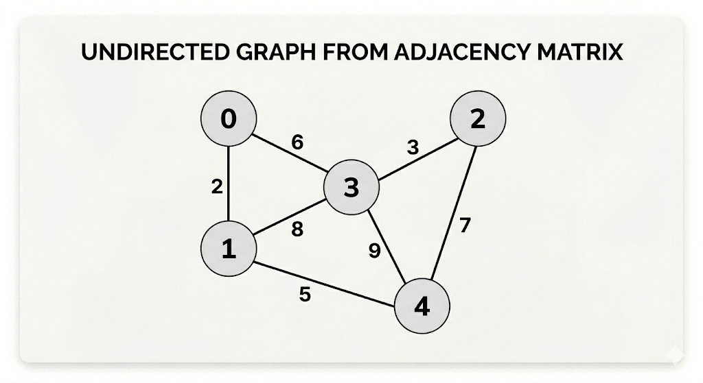
Steps (starting from vertex 0):
- Start: MST = {0}, key[0]=0
- Add edge 0-1 (weight 2) → MST = {0,1}
- Add edge 1-2 (weight 3) → MST = {0,1,2}
- Add edge 1-4 (weight 5) → MST = {0,1,2,4}
- Add edge 0-3 (weight 6) → MST = {0,1,2,3,4}
MST Edges: (0-1:2), (1-2:3), (1-4:5), (0-3:6) Total Cost: 16

Pseudocode (Simple Version)
function Prim(graph, V, start):
key = [infinity] * V
parent = [-1] * V
inMST = [False] * V

key[start] = 0
priority_queue = [] # (key, vertex)

while queue is not empty:
u = extract_min_vertex()
inMST[u] = True

for each neighbor v of u:
if not inMST[v] and graph[u][v] < key[v]:
key[v] = graph[u][v]
parent[v] = u
update priority queue

5. Time Complexity
Implementation | Time Complexity | Best For
Adjacency Matrix + Array | O(V²) | Dense graphs
Adjacency List + Binary Heap | O((E + V) log V) | Sparse graphs
Adjacency List + Fibonacci Heap | O(E + V log V) | Very dense graphs
- Space Complexity: O(V) or O(V + E)
Advantages:
- Simple and easy to understand/implement.
- Works very well on dense graphs (many edges).
- No need for explicit cycle checking (unlike Kruskal’s).
- Guarantees optimal MST.
Disadvantages:
- Slower on very sparse graphs compared to Kruskal’s.
- Requires priority queue (extra memory).
Krushkal’s Algorithm:
- Kruskal's Algorithm is a greedy algorithm used to find the Minimum Spanning Tree (MST) of a connected, undirected, weighted graph.
- It builds the MST by adding edges in increasing order of their weights, while avoiding cycles.
- Starts with a forest (each vertex as a separate tree) and gradually merges trees by adding safe edges.
- Uses Union-Find (Disjoint Set Union - DSU) data structure for efficient cycle detection.
Key Property: Always picks the smallest edge that does not form a cycle with the already selected edges.

2. Steps of Kruskal's Algorithm
- Sort all edges of the graph in non-decreasing order of their weights.
- Initialize each vertex as its own parent (create V disjoint sets).
- Initialize an empty MST.
- Iterate through the sorted edges:
  - Pick the smallest edge (u, v).
  - If u and v are not in the same component (i.e., find(u) != find(v)), add this edge to the MST and union the two sets.
  - If they are in the same component, discard the edge (it would form a cycle).
- Stop when the MST contains (V-1) edges (or all vertices are connected).
Result: The selected edges form the MST with minimum total weight.

3. Simple Example (Same Graph as Prim's for Easy Comparison)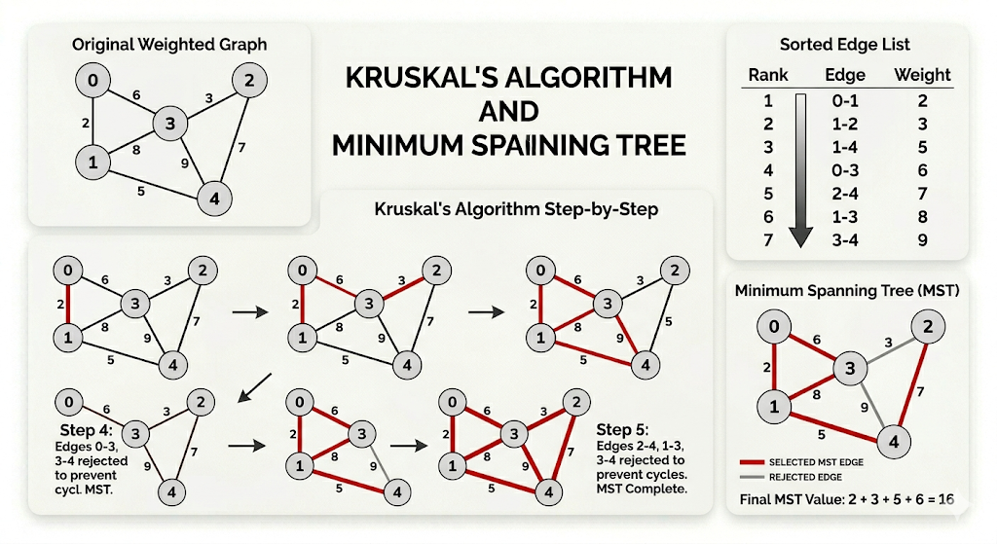
Steps:
- Add 0-1 (2) → Components: {0,1}, {2}, {3}, {4}
- Add 1-2 (3) → Components: {0,1,2}, {3}, {4}
- Add 1-4 (5) → Components: {0,1,2,4}, {3}
- Add 0-3 (6) → Components: {0,1,2,3,4} (Now 4 edges = V-1)
MST Edges: (0-1:2), (1-2:3), (1-4:5), (0-3:6) Total Cost: 16 (Same as Prim's)

Pseudocode
Python
function Kruskal(graph, V):
# Step 1: Create list of all edges
edges = []
for each edge (u, v, weight) in graph:
edges.append((weight, u, v))

# Step 2: Sort edges by weight
sort(edges)

parent = [i for i in range(V)] # Union-Find parent array
rank = [0] * V # For union by rank

mst_edges = []
total_cost = 0
edge_count = 0

for weight, u, v in edges:
if find(u, parent) != find(v, parent): # No cycle
mst_edges.append((u, v, weight))
union(u, v, parent, rank)
total_cost += weight
edge_count += 1
if edge_count == V-1:
break

return mst_edges, total_cost
Union-Find Helper Functions (Path Compression + Union by Rank):
- find(x): Returns the root parent of x
- union(x, y): Merges two sets

5. Time Complexity
- Sorting edges: O(E log E)
- Union-Find operations (with path compression + union by rank): Nearly O(E α(V)) where α(V) is very slow-growing (almost constant, ≤ 4 for practical V)
- Overall: O(E log E) or O(E log V) (since E ≤ V², log E ≈ 2 log V)
Space Complexity: O(E + V)
Best for: Sparse graphs (E << V²)

6. Advantages and Disadvantages
Advantages:
- Easy to implement.
- Works on disconnected graphs (produces Minimum Spanning Forest).
- Efficient for sparse graphs.
- No need to start from a specific vertex.
Disadvantages:
- Requires sorting all edges first.
- Union-Find adds slight implementation complexity.
- Slower on very dense graphs compared to optimized Prim's.

Kruskal’s vs Prim’s Algorithm (Most Important for Exams)
Feature | Kruskal's Algorithm | Prim's Algorithm
Approach | Edge-based (sorts all edges) | Vertex-based (grows from one vertex)
Starts with | Forest (each vertex separate) | Single arbitrary vertex
Data Structure | Union-Find (DSU) for cycle detection | Priority Queue (Min-Heap)
Cycle Detection | Explicit (using find/union) | Not needed (greedy growth prevents cycles)
Graph Representation | Edge List | Adjacency Matrix / List
Best for | Sparse graphs (few edges) | Dense graphs (many edges)
Time Complexity | O(E log E) or O(E log V) | O(V²) or O(E log V)
Handles Disconnected Graph | Yes (produces forest) | No (requires connected graph)
Rule of Thumb:
- Use Kruskal's → Sparse graphs or when edges are already sorted.
- Use Prim's → Dense graphs or when working with adjacency matrix.

8. Applications of Kruskal's Algorithm
- Network design (cables, roads, pipes) with minimum cost.
- Cluster analysis.
- Creating mazes or circuit wiring.
- Any problem requiring minimum cost to connect components without cycles.

